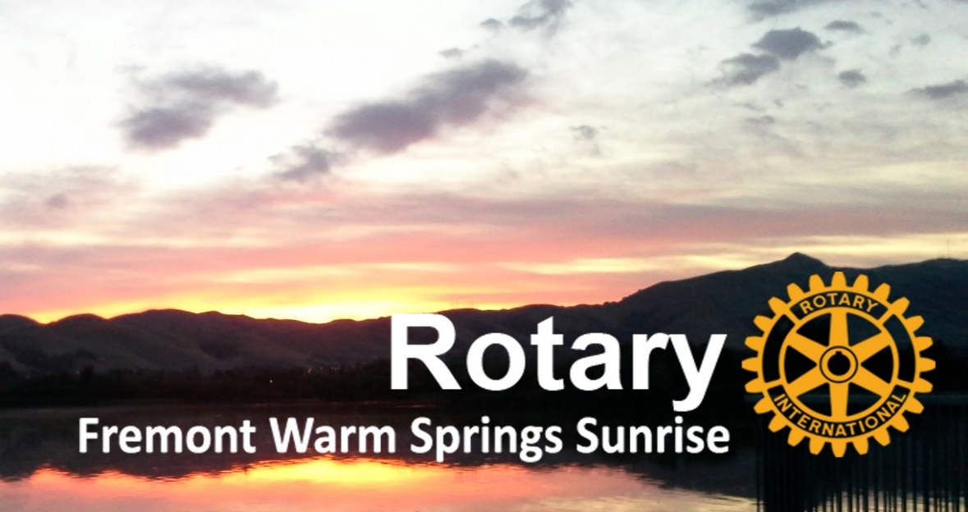

We Offer Opportunities To
Personally Make A Difference
And Have Fun Doing It

Basic Club Expectations:

- Regularly attend weekly morning Club meetings. Meetings begin with a social and networking period followed by either discussions of Club business, community service or fundraising projects, or presentations by guest speakers.
- Attend monthly social events whenever possible. Members usually meet for an evening dinner or other social activity the first week of each month in lieu of the regular weekly meeting.
- Members are encouraged to offer their time, and talent to Club committees and assignments. We plan, coordinate, and accomplish Club service opportunities, fundraising events and conduct other routine Club business functions.
- Members are encouraged to participate in Rotary Club, Area, District and Rotary International events and committees. This is how we learn more about what Rotary accomplishes, contribute to getting things done together on a larger scale and offers opportunities to network with a wide variety of members with like business and social interests.
- Contribute financially (to the extent members are able) to our Club’s nonprofit Foundation which funds our local programs and The Rotary Foundation which funds worldwide Rotary initiatives such as clean water, worldwide literacy and eradication of Polio across the globe.

www.FremontMorningRotary.org
www.facebook.com/FremontMorningRotary
Service to Our Community:

- Centerville Free Dining Room: Every fifth Tuesday of a month, we partner with the Rotary Club of Mission San Jose to volunteer our time to this organization to purchase, prepare and serve dinner to the homeless and hungry.
- Tri-City Rotary Clinic: We provide funding for all medicines and medical testing for SAVE and Abode Housing residents.
- Local Service Organizations: Members can propose volunteer or funding proposals for programs or projects of local service organizations that help those in need that fall within our capabilities and resources to serve. Members liaison with these organizations to establish a need and then develop and present proposals to the Club and our Foundation for action and/or funding. Once approved, Club members shepherd the proposals through completion. Recent examples of community organizations supported by our Club include: Life ElderCare Meals-on-Wheels, SAVE, Abode Housing, Fremont Senior Center and the Grateful Garment Project.

Service to Youth:

- Interact high school service clubs: We sponsor Interact Clubs at Irvington and Kennedy High Schools. Members can work with students to mentor and encourage their projects and include them in our service activities to teach them the value of Service Above Self. Members work with the Interact Clubs to select students for a winter Interact Retreat.
- Rotary Youth Leadership Awards (RYLA): Members help recruit and select high school students for Club funded scholarships to attend the RYLA summer camp. Members also work with these students to prepare a presentation of their experiences to the Club.
- High School Speech Contest: Each year the District sponsors a speech contest where students can learn about and raise awareness to issues related to Rotary Initiatives. Members work with Interact Clubs to recruit students and mentor them in developing their speeches. We also organize and coordinate our Club level contest, and follow the winner to the Area and District level contests.
- Reference Books for Kids: Each year our Club distributes reference books to every 5th grader in 11 local grammar schools to encourage them to develop increased literacy. The Club purchases about 1,000 dictionaries, thesauruses, or atlases for students. Members contact the schools to determine their needs, prepare the books, and deliver them through classrooms presentations. In some cases, these are the first books some students can all their own.
- ROTARACT: This is a college level service club associated with Rotary. We support each other’s fundraising activities. Local ROTARACT club has a representative in our weekly meeting.

Service Around the World:

- Members from each Rotary Club in our area pool their talent and funding to develop large scale international projects to the poorest nations around the world. This area committee is comprised of one or more members from each area Club.
- The committee reviews International Service project proposals from the clubs and seeks and writes proposals for matching Global Grants funded from The Rotary International Foundation partnering with Rotary Clubs around the world. Some recent projects are in Mexico, India, Nigeria and Ethiopia.
- Members also have opportunities to travel abroad to visit and assess progress of these projects for project completion and sustainability.

Take the next step. Email us at membership@FremontMorningRotary.org
We Will Meet With You to Talk More About Our Club or Arrange to Visit a Club Meeting

